A biography

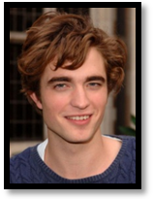

was born on May 13, 1986, in ,England. He



enjoys and is an excellent musician,
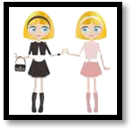
playing both the and the . He has two older , Lizzie and Victoria.

He remains close with Stanislav Ianevski and Katie
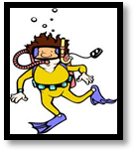
Leung (Harry Potter and the Gobleth of Fire,2005 co-stars).
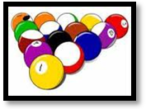

He was taught how to for his role in Harry Potter and the Gobleth of Fire (2005).

He has said that and are more his sport.

His father is a .
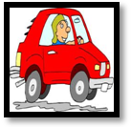
He learned to in a ten hour crash course on the set of Twilight.

Robert Pattinson was born on May 13, 1986, in London, England. He enjoys music and is an excellent musician, playing both the guitar and piano.
He has two older sisters, Lizzie and Victoria.
Remains close friends with Stanislav Ianevski and Katie Leung.
He was taught how to scuba dive for his role in Harry Potter and the Gobleth of Fire (2005).
He has said that darts and pool are more his sport.
His father is a car salesman.
He learned to drive in a ten hour crash course on the set of Twilight.

